SCUBA-2 Block Specification
fibre_rx_protocol

Table of Contents

1. Block Overview 3
1.1 Block Location and Block Interface Within System 3
1.2 Block Functionality / Features 3
1.3 Block Dataflow 4
2. Block Interfaces 5
2.1 Interface Signal Description 5
2.2 Interface Protocol and Timing 6
3. High-Level Description 8
3.1 State Machine Description 8
3.2 State Machine Outputs 9
4. Files of the Block 12
4.1 Source Code 12
4.1.1 rx_control_fsm.vhd 12

Block Overview

Block Location and Block Interface Within System
This block is located on the clock card FPGA. It is part of the fibre_rx block. It interfaces with the following blocks on the clock card:

- fibre_rx_fifo
- cmd_translator

Block Functionality / Features
- Monitors “rx_fifo” block for incoming commands.
- Checks all incoming commands are preceded by the appropriate preamble (otherwise disregarded).
- Reads in entire command and compares the sent checksum with locally calculated checksum. If they do not match the output line ‘cksum_err_o’ is asserted to enable block reply_data_fsm to return an error reply.
- If the checksum is correct then the command is made available to cmd_translator. The command code, card identifier, parameter identifier, and number of data words, all have separate output lines. The cmd_rdy_o line is asserted high when these outputs are ready to be processed.
- The additional data word/words of the command are clocked out on the cmd_data_o field once the command ready signal is acknowledge by “cmd_translator”. The reset, stop_application, and start_application commands have one data word, the write_block command has N data words (where N is in the range 1 → 58) and the read_block command has no data words.

Block Dataflow
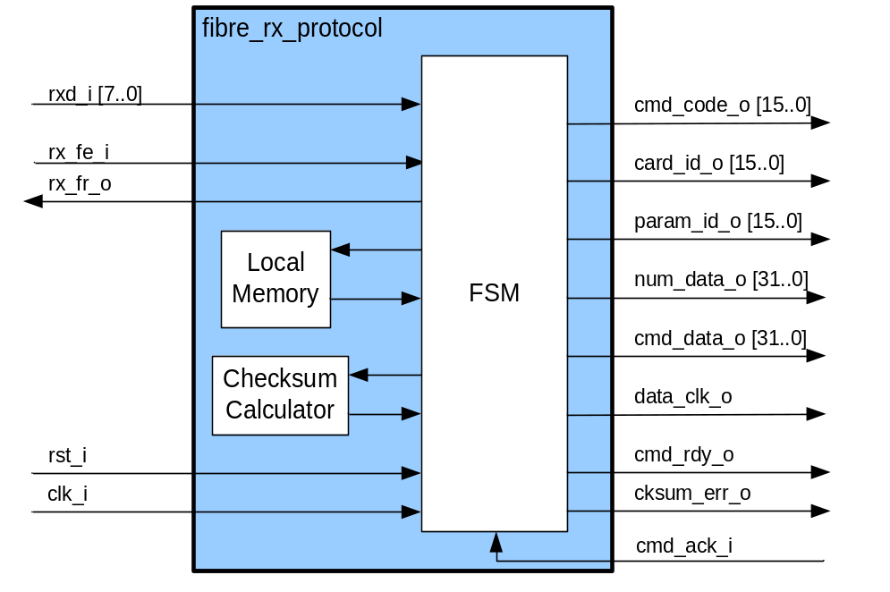

Block Interfaces

Interface Signal Description
- Interface Signals
Signal | Description | Direction
Global Signals
clk_i | Global clock signal | in
rst_i | Global asynchronous active-high reset | in
Control Signals
rx_fe_i | Receive FIFO empty line. Monitored to determine when a command is present to be processed. | in
cmd_ack_i | Once cmd_rdy_o has been asserted the FSM will wait for cmd_ack_i to be asserted high by the subsequent entity before clocking out the data words on “cmd_data_o.” | in
rx_fr_o | Receive FIFO request line. Asserted to get next byte of command. The byte is read through input ‘rxd_i’. | out
data_clk_o | Data Clock output. This is used to indicate when a new data word is present on cmd_data_o. data_clk_o is clocked once for the ST, GO, and RS commands, N times for WB command (where N = num_data_o), and 0 times for the RB command | out
cmd_rdy_o | Command Ready. This is asserted high after a command has been successfully read in by the FSM with no errors in the checksum. It indicates that cmd_code_o, card_addr_o, reg_addr_o, and num_data_o are available to be read by subsequent blocks.  Cmd_rdy_o is asserted high for the entire time that data is being clocked out. | out
cksum_err_o | Checksum error. If the transmitted checksum does not match the locally calculated one then this line is asserted. The reply_data_fsm block would then initiate an error reply message to the host. | out
Data Signals
rxd_i | byte wide data from FIFO received on request (by asserting rx_fr_o). | in
cmd_code_o | 16-bit command code. | out
card_id_o | 16-bit card identifier. | out
param_id_o | 16-bit parameter identifier. | out
num_data_o | 32-bit output indicating the number of data words. In the case of the WB command this indicates the size of the data block to be clocked out on the ‘cmd_data_o’ field. For the ST, GO and RS commands the value of this field is always equivalent to 1, indicating that one command argument word will be clocked out on the ‘cmd_data_o’. For the RB command this field indicates the number of data words to be read from memory and returned in the reply packet (no data words are clocked out on cmd_data_o). | out
cmd_data_o | 32-bit command data. For the ST, GO, and RS command one dummy word will be clocked out of this field. For the RB command no words will be clocked out of this field. For the WB command N words are clocked out of this field (where N = the number of valid data words to be written to memory) | Out

Interface Protocol and Timing
Consider the following write_block command, which contains 5 words of valid data:

Word 1: Preamble 1 0x A5A5A5A5
Word 2: Preamble 2 0x 5A5A5A5A
Word 3: WB Command 0x 20205742
Word 4: Address (card_id + param_id) 0x 0002015C
Word 5: Data Valid 0x 00000005
Word 6: Data V1 0x 01010101
Word 7: Data V2 0x 02020202
Word 8: Data V3 0x 03030303
Word 9: Data V4 0x 04040404
Word 10: Data V5 0x 05050505
Word 11..63: Data V6..V58 0x 00000000
Word 64: Checksum Sequential XOR of Words 3 → Word 64

This command would be buffered byte by byte (little endian) in the receiver FIFO ‘fibre_rx_fifo’ block. Once fibre_rx_protocol has read the bytes and processed the command its outputs would be as illustrated in Figure 2.1.

Note that if an error was found in the checksum, then ‘cksum_err_o’ would be asserted high so that an error reply could be generated, while ‘cmd_rdy_o’ and ‘data_clk_o’ would remain low.

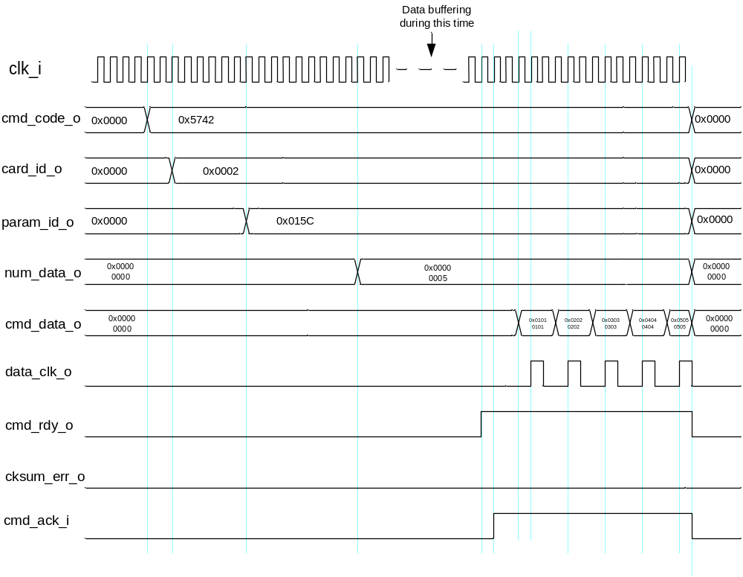
Figure 2.1: Timing Diagram

High-Level Description

State Machine Description

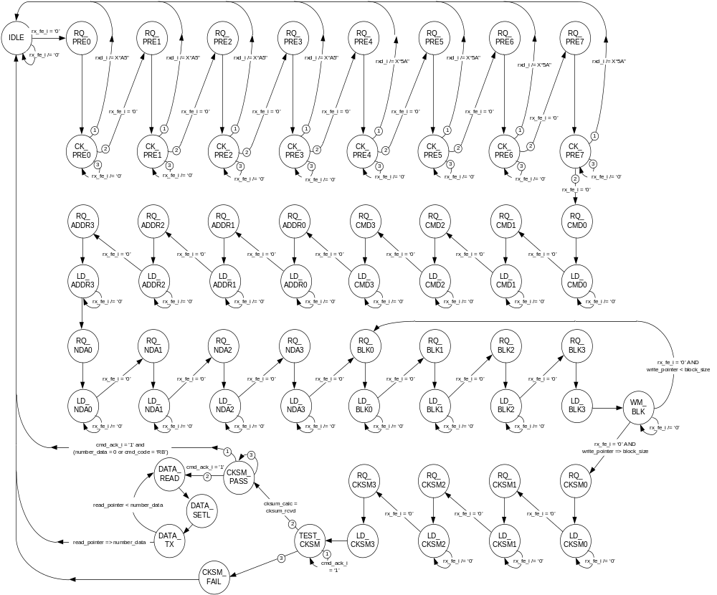

State Machine Outputs

Note that all the outputs including the string “sel” in their name are MUX selector lines used to path an incoming byte of data to an appropriate set of registers.

STATE |  | OUTPUTS
Default Assignments |  | cksum_err <= '0';  cmd_rdy <= '0';  rx_fr <= '0';  data_clk <= '0';  write_mem <= '0';  read_mem <= '0';  reset_mem <= '0';  check_update <= '0';  check_reset <= '0';  cmd_mux_sel0 <= '0';  cmd_mux_sel1 <= '0';  id_mux_sel0 <= '0';  id_mux_sel1 <= '0';  id_mux_sel2 <= '0';  id_mux_sel3 <= '0';  data_out_mux_sel0<=‘0’; | nda_mux_sel0 <= '0';  nda_mux_sel1 <= '0';  nda_mux_sel2 <= '0';  nda_mux_sel3 <= '0';  ckin_mux_sel0 <= '0';  ckin_mux_sel1 <= '0';  ckin_mux_sel2 <= '0';  ckin_mux_sel3 <= '0';  ckrx_mux_sel0 <= '0';  ckrx_mux_sel1 <= '0';  ckrx_mux_sel2 <= '0';  ckrx_mux_sel3 <= '0';  data_in_mux_sel0 <=‘0’;  data_in_mux_sel1 <=‘0’;  data_in_mux_sel2 <=‘0’;  data_in_mux_sel3 <=‘0’;
IDLE | 000000 | reset_mem <= '1';  check_reset <= '1'; | data_out_mux_sel0<=‘1’;
RQ_PRE0 | 000001 | rx_fr <= '1' ;
CK_PRE0 | 000010
RQ_PRE1 | 000011 | rx_fr <= '1' ;
CK_PRE1 | 000100
RQ_PRE2 | 000101 | rx_fr <= '1' ;
CK_PRE2 | 000110
RQ_PRE3 | 000111 | rx_fr <= '1' ;
CK_PRE3 | 001000
RQ_PRE4 | 001001 | rx_fr <= '1' ;
CK_PRE4 | 001010
RQ_PRE5 | 001011 | rx_fr <= '1' ;
CK_PRE5 | 001100
RQ_PRE6 | 001101 | rx_fr <= '1' ;
CK_PRE6 | 001110
RQ_PRE7 | 001111 | rx_fr <= '1' ;
CK_PRE7 | 010000
RQ_CMD0 | 010001 | rx_fr <= '1' ;
LD_CMD0 | 010010 | cmd_mux_sel0 <= '1'; | ckin_mux_sel0 <= '1';
RQ_CMD1 | 010011 | rx_fr <= '1' ;
LD_CMD1 | 010100 | cmd_mux_sel1 <= '1'; | ckin_mux_sel1 <= '1';
RQ_CMD2 | 010101 | rx_fr <= '1' ;
LD_CMD2 | 010110 |  | ckin_mux_sel2 <= '1';
RQ_CMD3 | 010111 | rx_fr <= '1' ;
LD_CMD3 | 011000 |  | ckin_mux_sel3 <= '1';
RQ_ID0 | 011001 | rx_fr <= '1' ; | check_update <= '1';
LD_ID0 | 011010 | id_mux_sel0 <= '1'; | ckin_mux_sel0 <= '1';
RQ_ID1 | 011011 | rx_fr <= '1' ;
LD_ID1 | 011100 | id_mux_sel1 <= '1'; | ckin_mux_sel1 <= '1';
RQ_ID2 | 011101 | rx_fr <= '1' ;
LD_ID2 | 011110 | id_mux_sel2 <= '1'; | ckin_mux_sel2 <= '1';
RQ_ID3 | 011111 | rx_fr <= '1' ;
LD_ID3 | 100000 | id_mux_sel3 <= '1'; | ckin_mux_sel3 <= '1';
RQ_CKSM0 | 100001 | rx_fr <= '1' ; | check_update <= '1';
LD_CKSM0 | 100010 | ckrx_mux_sel0 <= '1';
RQ_CKSM1 | 100011 | rx_fr <= '1' ;
LD_CKSM1 | 100100 | ckrx_mux_sel1 <= '1';
RQ_CKSM2 | 100101 | rx_fr <= '1' ;
LD_CKSM2 | 100110 | ckrx_mux_sel2 <= '1';
RQ_CKSM3 | 100111 | rx_fr <= '1' ;
LD_CKSM3 | 101000 | ckrx_mux_sel3 <= '1';
RQ_NDA0 | 101001 | rx_fr <= '1' ; | check_update <= '1';
LD_NDA0 | 101010 | nda_mux_sel0 <= '1'; | ckin_mux_sel0 <= '1';
RQ_NDA1 | 101011 | rx_fr <= '1' ;
LD_NDA1 | 101100 | nda_mux_sel1 <= '1'; | ckin_mux_sel1 <= '1';
RQ_NDA2 | 101101 | rx_fr <= '1' ;
LD_NDA2 | 101110 | nda_mux_sel2 <= '1'; | ckin_mux_sel2 <= '1';
RQ_NDA3 | 101111 | rx_fr <= '1' ;
LD_NDA3 | 110000 | nda_mux_sel3 <= '1'; | ckin_mux_sel3 <= '1';
RQ_BLK0 | 110001 | rx_fr <= '1' ; | check_update <= '1';
LD_BLK0 | 110010 | data_in_mux_sel0 <= '1'; | ckin_mux_sel0 <= '1';
RQ_BLK1 | 110011 | rx_fr <= '1' ;
LD_BLK1 | 110100 | data_in_mux_sel1 <= '1'; | ckin_mux_sel1 <= '1';
RQ_BLK2 | 110101 | rx_fr <= '1' ;
LD_BLK2 | 110110 | data_in_mux_sel2 <= '1'; | ckin_mux_sel2 <= '1';
RQ_BLK3 | 110111 | rx_fr <= '1' ;
LD_BLK3 | 111000 | data_in_mux_sel3 <= '1'; | ckin_mux_sel3 <= '1';
WM_BLK | 111001 | write_mem <= ‘1’
TEST_CKSUM | 111010
CKSM_FAIL | 111011 | cksum_err <= '1' ;
CKSUM_PASS | 111100 | cmd_rdy <= '1' ;
DATA_READ | 111101 | read_mem <= ‘1’ ;  cmd_rdy <= '1'; | data_out_mux_sel <= '1' ;
DATA_SETL | 111110 | cmd_rdy <= '1';
DATA_TX | 111111 | cmd_rdy <= ‘1’; | data_clk <= ‘1’

Files of the Block

Source Code

fibre_rx_protocol.vhd

